What to Look Out For: Substance Use Awareness Month October 2015
During their teen years, adolescents face many challenges and begin to make personal decisions such as whether or not to use alcohol and other drugs. Teens who begin to use substances go to great lengths to conceal what they are doing and quickly learn ways to enhance their high. Often, by the time teens are caught using substances by their parents, they have been using alcohol and other drugs for quite some time. If you suspect your child is using substances the images below might help you to learn how teens might conceal their involvement and what measures they take to achieve a greater high.

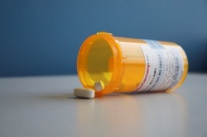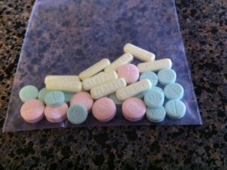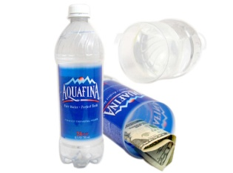
(Above) A growing number of young people are misusing prescription drugs such as OxyContin (opioid pain medication), Xanax (anxiety medication), and Ritalin (stimulant ADHD medication). Teens often access medication from the home medicine cabinet and from the homes of their friends. They can also buy these medications on the internet. Opioid misuse can easily lead to the use of heroin. Adolescents hide drugs and cash in fake water bottles which come apart revealing a stash compartment.

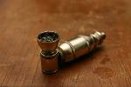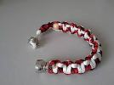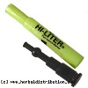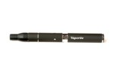
(Above) You might easily recognize the marijuana pipe on the far left but young people might also utilize a pipe disguised as a bracelet, a pipe contained in an empty highlighter cylinder or a vape pen to smoke marijuana. The vape pen is popular because it greatly cuts down on the odor emitted when marijuana is smoked.

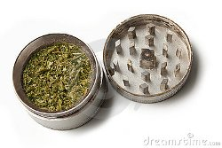
(Left) This is a grinder used to grind down the buds of marijuana. The container has two compartments. The bottom compartment collects what users call “kief” or “keef” which comes from grinding the crystals from the buds of marijuana. “Kief” contains the highest level of THC.

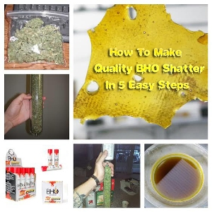
(Top) To enhance the potency of marijuana young people sometimes process marijuana to make what is called “dab” or “shatter”. Marijuana is packed tightly in a tube. The bottom of the tube is closed in by coffee filters and secured with elastics. Butane fluid is dripped over the marijuana at the open end of the tube. Below the tube a small bowl is placed to catch the drippings. The butane is used to release the THC concentrates from the marijuana. The bowl is then placed in a pan of hot water to help the butane to evaporate. The concentrate (dab) is left to cool and solidify. The dab is then put on the surface of a smoking device which has been heated by a butane torch and inhaled. The effects of dab are much more potent than traditional marijuana. It should be noted that making dab in this manner is dangerous as explosions can occur. If you find a butane torch, a tube, and butane in your child’s room it is likely that they are involved in making dab. Teens find instructions to make dab from the internet and by consulting with other users.

(Center) Dab is stored in small round containers that resemble lip balm tins. Dab is amber in color and sticky to the touch.

(Bottom) Since users have found that making dab with butane can be dangerous they have found an alternative way of making marijuana concentrates. Users are now wrapping marijuana buds in parchment paper and clamping the drug between the hot plates of a hair straightener device. The drippings from the marijuana fall on the parchment paper and are cooled. The dab is then smoked as described above.
